The Trans-Siberian Railway
The Ultimate Rail Journey ~ by Matt Scott

The Trans-Siberian Railway is the ultimate rail journey, the longest in the world, possibly the coldest if you go at the wrong time of year and the only journey that travels in two continents in a single journey while staying in the same country. Without leaving your seat you can make your way across almost a third of the globe. The Trans Siberian is the most amazing train journey on Earth.  There are three routes that travellers can take to explore the area of Siberia. The Moscow to Vladivostok route is over 6000 miles long, and there are also two routes that leave Moscow heading to Beijing, one going through Mongolia, taking six days and travelling almost 5000 miles or one that travels via Manchuria, which takes almost a week to complete. I was intrigued by the country that was home of Genghis Kahn and… Well I didn’t know what else, which was part of the reason I was intrigued.
  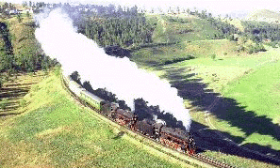
  
.
Have you ever made this journey? Would you like to?

What else do you know about it?

What are the advantages of traveling in this way, as opposed to flying?

What superlatives does the writer use to describe the Trans-Siberian?

Using your own knowledge (or your imagination), what other superlatives could you use?

So how do you think travelling by train in Siberia compares to traveling by train in Europe? Make some comparisons.

Do you think it’s better to fly in Europe or travel by train?

Do you know how much British train fares are?

And do you know how much European cheap flights cost?

